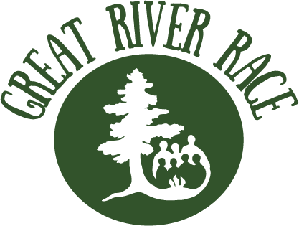

Team Roster Sign-Up

Return to Wilderness Inquiry by September 4, 2020

On September 12, 2020, Wilderness Inquiry, in partnership with the National Park Service, City of Minneapolis, and City of Saint Paul will host the Great River Race - a canoe race and community celebration on the Mississippi River. The Great River Race increases awareness of the academic achievement gap in Minnesota and raises funds for Canoemobile, a high-quality outdoor education program that connects underserved students to the outdoors. Sign up today to help close the achievement gap!

Great River Race boats need 7-9 paddlers (one of whom is the Team Captain).
Please provide one sign-up sheet per boat.

Sponsor Organization: |  | Team/Boat Name:
Team Captain Name: |  | Email:
Office Phone: |  | Cell Phone:

Team Info
Paddler Name | Email | Cell Phone | T-Shirt Size (Unisex)
* 1.
2.
3.
4.
5.
6.
7.
8.
9.
Alternates
* Asterisk denotes Team Captain
Send to Willy Tully at willy@wildernessinquiry.org by September 4, 2020.

