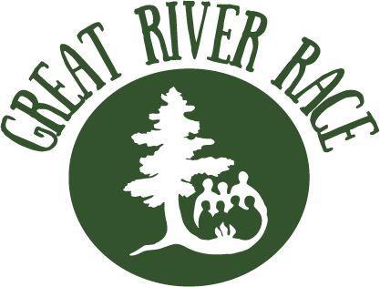

Race Sign-Up

Due to Wilderness Inquiry September 6, 2018

On September 15, 2018, Wilderness Inquiry, The McKnight Foundation, and the National Park Service will bring together teams to compete in a canoe race on the Mississippi River. This Great River Race will increase awareness of the academic achievement gap in the Twin Cities and raise funds for Canoemobile, a high-quality outdoor education initiative designed to help disadvantaged students succeed. Sign up to help close the achievement gap today!

Great River Race boats need 7-9 paddlers (one of whom can be the Team Captain).
Please provide one sign-up sheet per boat.

Sponsor Organization: |  | Team/Boat Name:
Team Captain Name: |  | Email:
Office Phone: |  | Cell Phone:

Team Info
Paddler Name | Email | Cell Phone | T-Shirt Size (Unisex)
1.
2.
3.
4.
5.
6.
7.
8.
Alternates

Send to Willy Tully at willy@wildernessinquiry.org by September 6, 2018.
Please don’t hesitate to reach out with questions – 612-676-9430.

