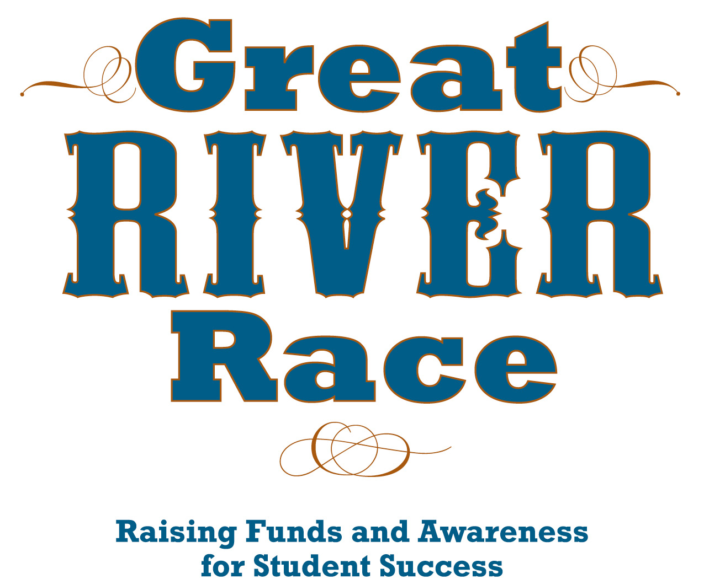
RACING TIPS

The Great River Race is a staggered start race. Boats will cross the starting line in flights of four to six boats. It doesn’t matter what number you are in the launch sequence; your official time begins when your bow crosses the starting line.

What makes a staggered start race exciting is that you never know who is winning until all split times are calculated at the end. Your goal is to work together to move your boat quickly, safely and efficiently towards the finish line – and to safely pass as many boats as possible along the way.

When starting a stage of the race, think about hitting the starting line at full race pace, or as fast as you think you can get your canoe moving. This means building speed and power as you leave a staging area and head toward the starting line, which will be marked with red Coast Guard or floating inflatable buoys (and in some cases, our race officials tent). Remember: In order for our race officials to get accurate starting times for each boat, there is no passing until you have crossed the starting line.

The Great River Race is an 6-mile race from Hidden Falls Park, around Pike Island, and returning to Hidden Falls Park.

The goal to is keep your canoe moving at a strong, steady-state paddle rate. Any time you pass a boat, you’re improving your chances of winning, so use passing a boat as motivation to bring the pace up. To keep the energy up in your boat, designate a team booster or have your team captain call some focus drills, like “take 10 power strokes for the UWCA” or take “10 speed-up strokes for our team captain Joe,” etc. You can also use landmarks to keep the pace up: “add speed and power through the next green buoy.”

Additional Thoughts:
Always listen to your boat captain (in the stern). Trust that your boat captain is doing his or her best to make your boat fast (and safe).

Always listen and follow any safety instructions from the race pontoon boats -- and any other safety officials on the water.

Don’t focus on where you start in the line-up. With staggered start racing, you never really know who is in the lead. Race hard and don’t let up even if you think you’re ahead. A boat several places back could be passing boats, making up time and pulling off the win!

HAVE FUN! This is a race, but it’s also a glorious way to spend a fall day on the river for a great cause!

