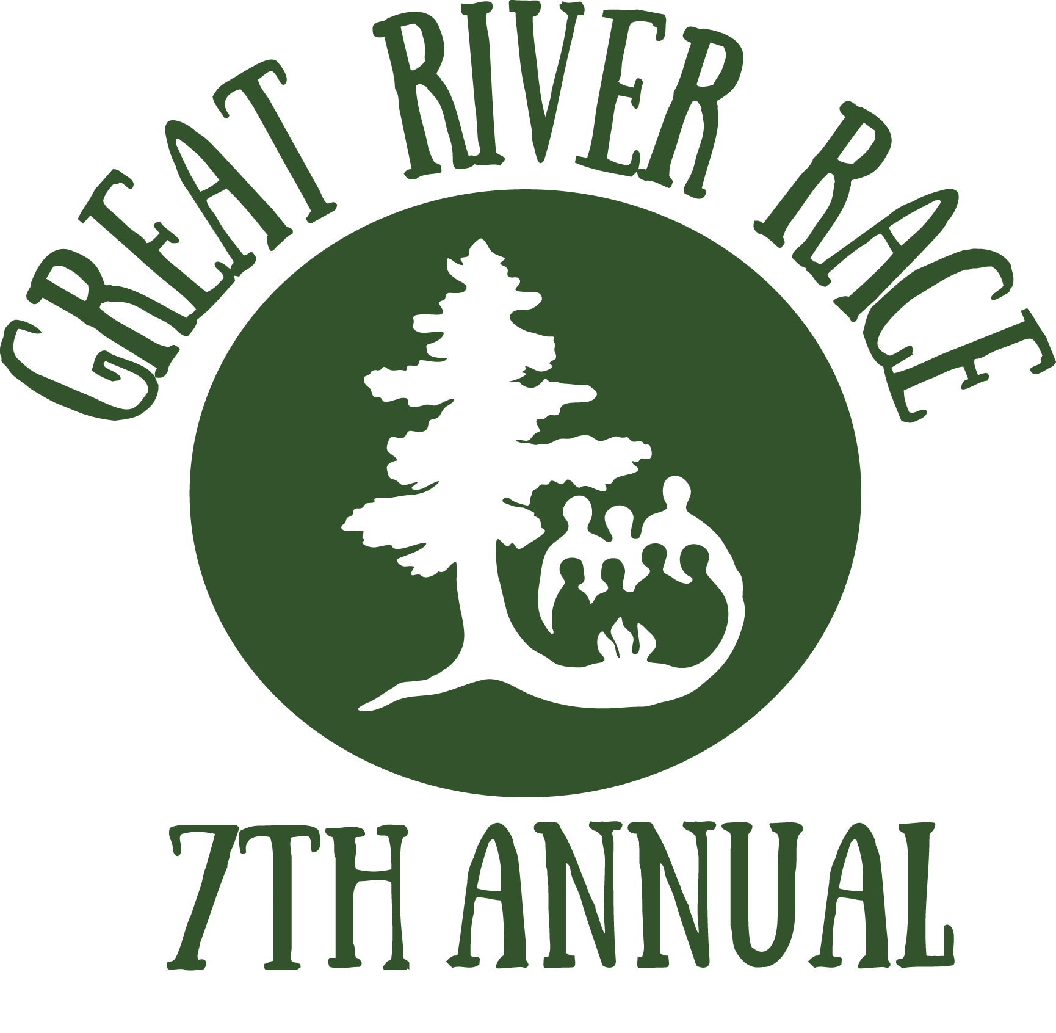
Race Day Information Sheet Saturday, September 16, 2017
Thank you for participating in the 7th Annual Great River Race, and for helping raise funds and awareness for student success. You’ll be one of 30 teams paddling to win – but in the end, everybody wins as all race proceeds benefit Canoemobile MN’s creative outdoor education program initiatives designed to address the academic achievement gap.
The Great River Race is an approx. 6-mile canoe race from Hidden Falls Regional Park, around Pike Island, and back to Hidden Falls. Please note the route may change based on river levels and weather.
This is a staggered start race – the type often used in competitive rowing regattas held on rivers. Boats will cross the starting line in flights of 4-6 boats. It doesn’t matter what number you are in the launch sequence; your official time begins when your bow crosses the starting line. You never know who is winning in a staggered start race until the end when all split times are calculated. Your goal in a staggered start race is to work together to move your boat quickly, safely, and efficiently towards the finish line – and to safely pass as many boats as possible along the way.
You will be racing in a 24’ Voyageur canoe, led by an experienced Wilderness Inquiry boat captain in the stern. Paddles and life jackets will be provided for all racers. Each canoe will carry a dry bag for small personal items. Note that all on-the-water times presented here are estimated. A strong tail wind could make the race go faster; a strong head wind could slow us down.
In case of emergency: If your family needs to reach you while you’re on the water, they should contact Nell Holden at 612-202-4510. She will be on-site and in radio contact with the race all day.
Race Detailed Itinerary
8:30-9 a.m. ARRIVE at the North Gate of Hidden Falls Regional Park, which is located near the intersection of S. Mississippi River Blvd and Magoffin Ave. in Saint Paul. Here’s a map: http://goo.gl/TcMsT Race volunteers will direct you to parking. For a spot in the park, please arrive early (and carpool if possible). Overflow street parking will be available in the adjacent neighborhood. Upon arrival, check in and meet your team. Restrooms, coffee, and a snack will be available.

9:00 a.m. Brief program and RACE OVERVIEW, with an explanation of race route.
* During the program, your team will be given a bow number. When your team is called, your team captain should go to the stage to get your canoe’s stern flag.

9:30 a.m. Team Huddles: Gather with your team at an assigned equipment tarp. Select paddles and life jackets. Your Wilderness Inquiry boat captain will provide a quick paddle demo and safety talk. You and your team can discuss race strategy and have final preparation.

9:45 a.m. First Flight of canoes moves to the canoe launch area. We will launch flights of 4-6 canoes at a time, at the direction of course master.

10:00 a.m. Paddles in water. RACE BEGINS!

11:30 a.m. First boats finish. We estimate that canoes will cross the Finish Line at Hidden Falls between 11AM and 12PM.
*After landing, your Wilderness Inquiry boat captain will guide you in carrying gear and the canoe to a staging location.

12:00 noon PICNIC LUNCH / AWARDS CEREMONY
Join your fellow racers for lunch and festive music by Gravel on Mud. Once everyone has their lunch, trophies will be awarded for first, second and third place. A Team Spirit award and greatest fundraiser award will also be presented. Be sure to grab your Great River Race t-shirt at the lunch tent!

1:00 p.m. Event concludes. Join after to launch the Bancroft Arnesen “Access Water” Expedition.

