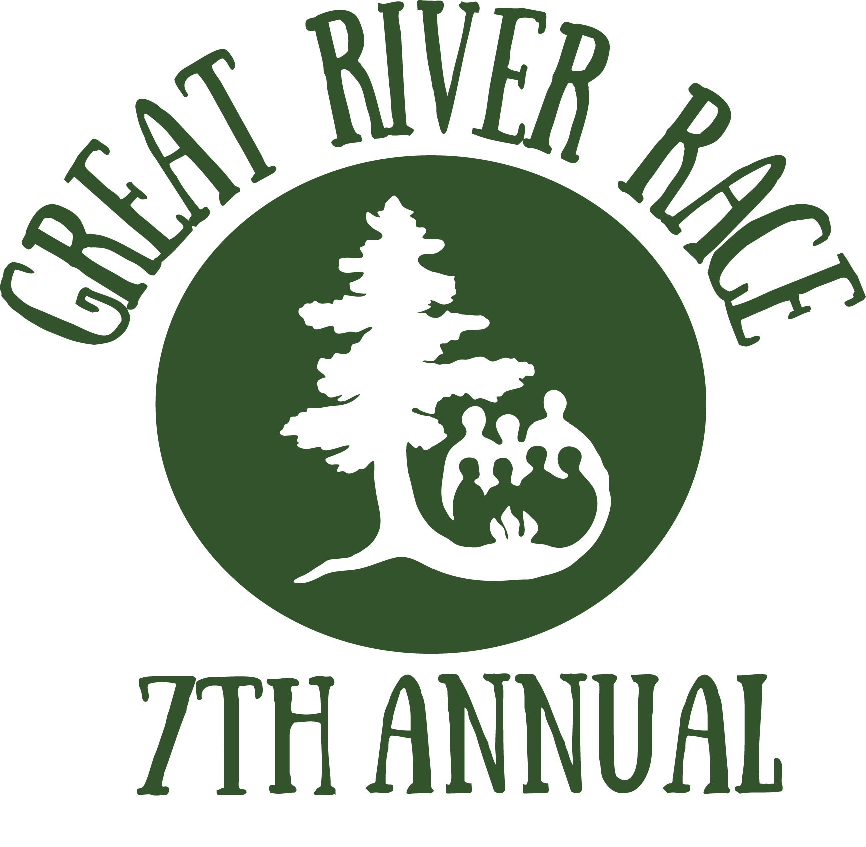

Race Sign-Up
Due to Wilderness Inquiry September 6, 2017

On September 16, 2017, Wilderness Inquiry, the National Park Service and the Mississippi Park Connection will bring together teams to compete in a canoe race on the Mississippi River. This Great River Race will increase awareness of the academic achievement gap in the Twin Cities and raise funds for Canoemobile, a high-quality outdoor education initiative designed to help disadvantaged students succeed. Sign up to help close the achievement gap today!
Great River Race boats need 7-9 paddlers, one of whom can be the Team Captain.
Please provide one sign-up sheet per boat.

Sponsor Organization: |  | Team/Boat Name:
Team Captain Name: |  | Email:
Office Phone: |  | Cell Phone:

Paddlers:
Paddler Name | Email | Office Phone: | Cell Phone: | T-Shirt Size:
1.
2.
3.
4.
5.
6
7.
8.
Alternates:

Send to dorothy@wildernessinquiry.org by September 6, 2017. Questions - 612-676-9430.

